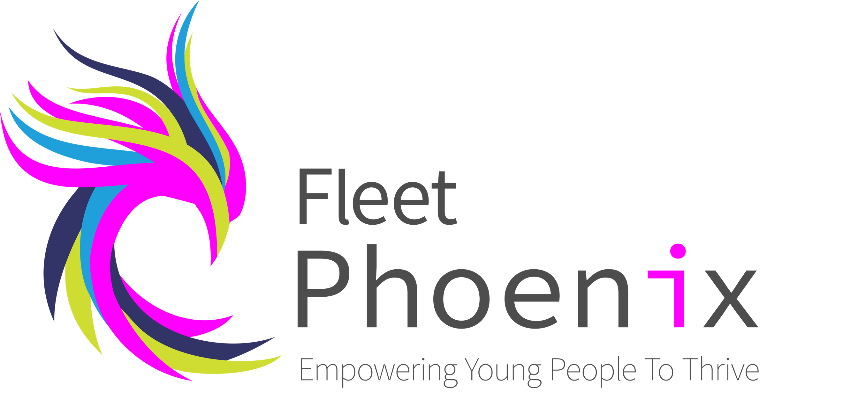

OFFICE ONLY:
Date received:

Fleet Phoenix
Open Door New Client Form

About the person making the referral
Name
Organisation
Contact details - email & phone number

Name of young person
Address | Postcode:
Telephone No Home
Mobile No
Date of Birth
Gender | Male / Female
School Year
School & named person contact details
Name of GP & Surgery | Phone no:
Are there any other professional workings with you?

If Yes - Name, service & contacts please
Please use reverse if more than one is involved.
Housing situation
Health issues to be aware of:
(physical and/or mental)
Disabilities to be aware of:
Learning difficulties to be aware of:
Has the client (young person) agreed for their information to be shared with Fleet Phoenix? | Yes/No
Has the client’s parent / guardian agreed for their information to be shared with Fleet Phoenix? | Yes/No
Parent/Guardian name:
Parent/Guardian address if different from client
Parent/ Guardian contact details | Email-  Landline-  Mobile-
Please give us as much information as you can about the issue you are referring the young person to us for including any work previously undertaken, family situation/issues & anything you believe to be impacting on the young person’s life.
Some insight into their behaviour, character & family dynamics would be useful.
Please also forward any formal paperwork you have for this young person along with the completed form to: Charlotte.tickner@fleetphoenix.co.uk

How can we help?
You’re input on the client needs is essential for us to know if we are able to support and to be able to appropriately appoint a specialist team member.

Let’s talk about your privacy:

Fleet Phoenix would like your permission to retain your details on our Data Base. This information is held confidentially and only the right people have access to your information.

We would like your consent for the following:

Consent to retain your information: Yes/No (This is a highly secure, cloud-based Data Base).

Consent to sharing information: Yes/No (This will only ever be done in your best interests. We never share your information for marketing purpose or with anyone that is not connected to your life/issues).

Remember……………

As an organisation we must keep your information safe and is protected by the General Data Protection Regulation (GDPR) 2016.

You have the right to withdraw your consent anytime. We will keep your information all the time you have the right to our support and will contact you when you are 25 to ask if you wish us to keep information archived.
You can change your mind who we can share information with at any time. If you require a copy of our Data Protection Policy, please contact the Fleet Phoenix main office - 01252 812308 or charlotte.tickner@fleetphoenix.co.uk

Date:

Signed (Client):

Notes:

